

|  |  |  |
| --- | --- | --- |
| |  | | --- | |  | | **PES University, Bengaluru** |
|  | (Established under Karnataka Act 16 of 2013) |
| **Department of Computer Science & Engineering** | |
| **Session: Jan - May 2022** | |

**UE19CS353 – Object Oriented Analysis and Design with Java**

**Theory ISA (Mini Project)**

Report on

**Payroll System**

**By:**

**Ashish Anand - PES1UG19CS094**

**Basavaraj Harvi - PES1UG19CS108**

**Chandan - PES1UG19CS122**

**6th Semester B section**

1. **Project Description :**

**Payroll management system is a administrative software tool to effectively manage employee details, salary reports and modifications to salaries based on employee performance. It can also be used to manage the leave application submitted by employees. It is also helpful for keeping track of reports generated by the various employees.In this software we can provide privilege to various users and grant them permission based on their roles in the company.**

**Link to Github repository:**

**<https://github.com/Radioactive-67/Payroll>**

1. **Analysis and Design Models :**

**We are using Incremental Design ,we implemented each section(Manager,Accountant,Employee) incrementally which simplified the Development Process**

1. **Tools and Frameworks Used :**

**NetBeans IDE**

**Swing Library**

1. **Design Principles and Design Patterns Applied**

**Singleton: Used in Database.java for connecting to database,as connecting to database is computationally expensive procedure,so by utilising singleton pattern we ensure that this process occurs only once.**

1. **Application Screenshots (3-4 important pages)**

**Home Screen(All the 3 section are visible Manager,Accountant and Employee).**

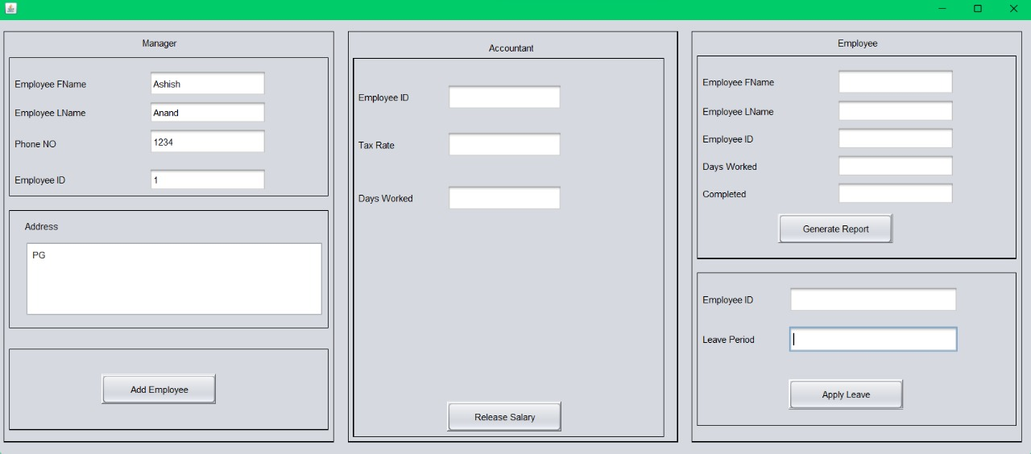

**Add Employee Button pressed and database has been updated accordingly.**

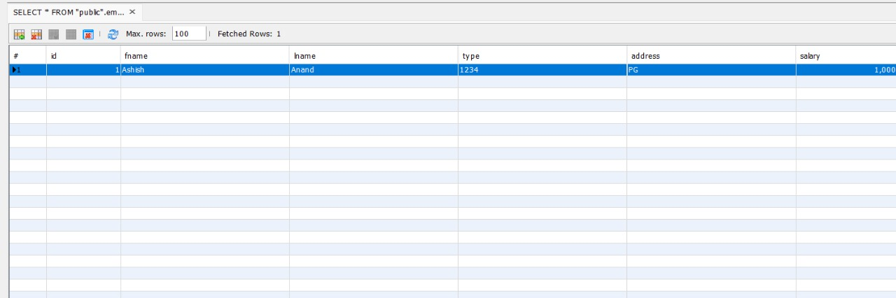

**Release Salary button pressed and pay Slip generated with tax calculations handled by the software.**

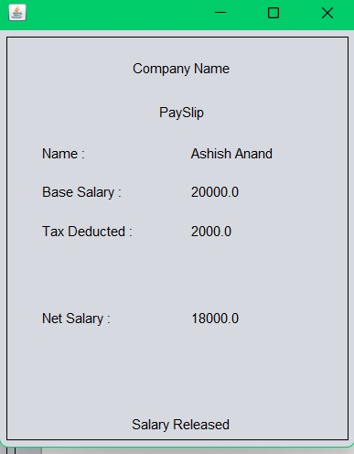

**Progress Report generated by the employee as per the details entered**

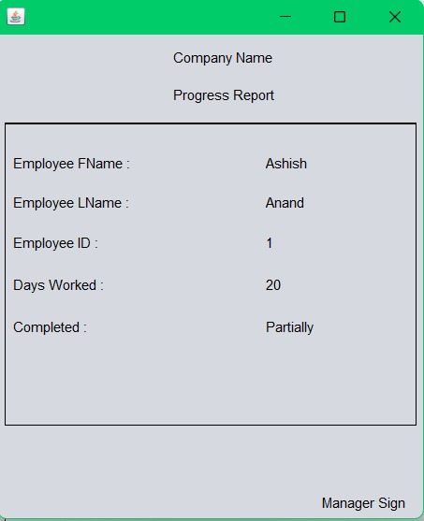

**Leave Application generated and penalty calculated after pressing the Apply Leave Button.**

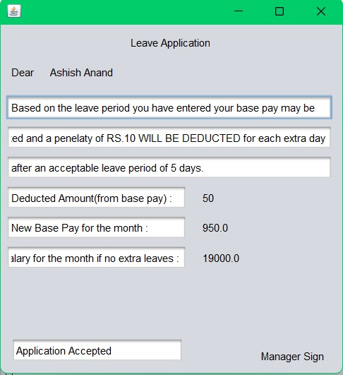

**New salary after deducting tax and leave penalty.**

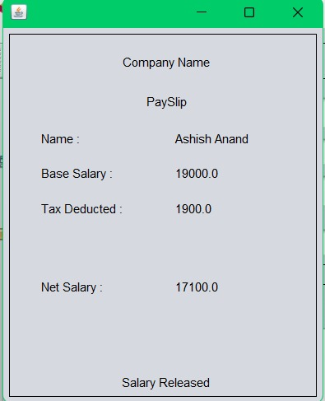

**Database Table updated after penalty deduction.**

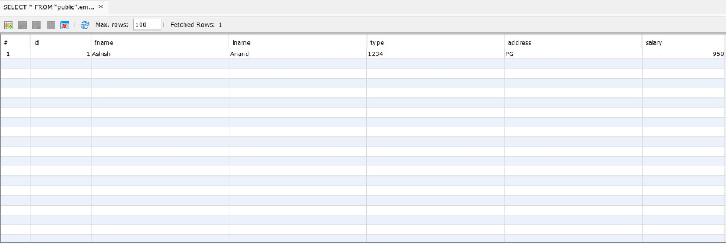

1. **Team member contributions :**

**Ashish Anand - Manager Section and Database operations(connection and modifications)**

**Chandan - Accountant Section and tax calculations**

**Basavraj Harvi - Employee Section and leave Application**